9 Inserting Urbanity in a Modern Environment
Frederico de Holanda

Abstract Teaching urban design in Brasilia is a peculiar challenge, for the city is a World Cultural Heritage Site. A big issue is the immensity of open unused spaces, which are, at the same time, a great asset. The students are first introduced to a way of looking at the city through various dimensions, or aspects of performance of urban morphology – i.e. its spaces (voids) and its forms (volumes). They become aware that city form may have contradictory performances: good in aesthetics, bad in functionality, for instance. In stage two, they apply this theoretical framework to a real situation. The identification of problems is the result. There follows three or four design stages. In each stage a dimension of performance is brought to frontstage, notwithstanding an underlying reflection on the other set of dimensions, but which remain rather in the background. Stage by stage, additional dimensions are brought to frontstage until all of them have been covered by the end of the semester. The aim is to introduce more livability – that is urbanity – in the city fabric. The specificities of Brasilia are the ‘jewel of the crown’ in this process: how to deal with a site which has essential undisputable qualities that must be preserved, not only for the sake of history but for the sake of timeless morphological qualities, and, at the same time, to mend its obvious – and serious – problems.

Keywords: Brasilia; modern architecture; heritage site; urbanity; urban design studio

9.1 Introduction

In 1984 a group of teachers was organised at the School of Architecture, University of Brasília, Brazil, which has been working, since then, with an ‘aspectual’ or ‘dimensional’ approach to architecture, in design studios and in theoretical courses (the group, called Morphological Dimensions of the Urbanisation Process, still exists, is officially recognised by the National Research Council, Brazil, and is coordinated by this author). The first idea: architecture must be addressed both as a dependent variable and as an independent variable. In the first case (dependent variable), it results from socioeconomic, political and ideological circumstances, as well as from the natural environment. In the second case (independent variable), it impacts the natural environment and the people, in the latter case both affecting bodies and minds. In this chapter, the focus is on design (not theoretical courses) and architecture will be considered as an independent variable (not a dependent one).
The idea of analysing architecture through aspects or dimensions is not new. It dates back at least to Vitruvius, with his three categories firmitas, utilitas and venustas (Vitruvius 1960 [27 BC)]). In recent times the idea was rescued by Bill Hillier and Adrian Leaman (1974) in the now classic essay ‘How is design possible?’. They propose a ‘four-function model’ for architecture, by which buildings and settlements act as ‘modifiers’ concerning man-man and man-nature relations. The four aspects are behaviour modifier, symbolic modifier, climate modifier and resource modifier.
Inspired by these ideas I have developed an eight-function model, but with a focus on people (not on environment, which is dealt elsewhere), and in two broad categories: the practical and the expressive implications of architecture to people. Upon reflection, these ideas are also akin to the basic tenets of Space Syntax Theory (henceforth SST), as put forward in a comprehensive way for the first time in ‘The Social Logic of Space’, by Bill Hillier and Julienne Hanson (1984). Architecture is understood in two ways. The first is that it affects us materially, does things to us, constitutes our lives, relates to our ‘ways of being in and moving through space’, thus impacting directly our bodies or the material issues implicated in the reproduction of human life (as ‘climatic modifier’ or ‘resource modifier’ functions, by Hillier and Leaman 1974). The second way through which architecture has effects upon us is expressive: it affects us by expressing symbols, emotions, identity and beauty.
As it is often the case, it is not easy to disentangle these two: what it does and what it expresses – they result from abstract reasoning. Modes of distributing ourselves in space (‘doing’ mode) impinge upon states of mind (‘expressive’ mode), and vice-versa: the exceptional beauty of a place (‘expressive’ mode) may lead ourselves to move to the location (‘doing’ mode). Thus, modes of affection of the body and of the mind are deeply interconnected, but may be, and should be analytically considered separately. This is the hypothesis I have been working with. In the first part of this chapter I will discuss these ‘aspects’ or ‘dimensions’ of architecture.
As the emphasis is on design, the second part will discuss the procedures carried out in urban configuration proposals. The source of inspiration is Bill Hillier’s ‘conjecture-test’ scheme, as presented in the final chapter of ‘Space is the machine’ (Hillier 1996). The students are challenged to face a current architectural problem at the scale of the city, preferably a problem present in local newspapers headlines.
The third part of the chapter deals with assessment. Once formulated the hypothesis, what criteria do we apply to evaluate whether the new situation advances in relation to the problematic status quo? How are these criteria to be considered consciously, considering that, yes, there are universal assumptions concerning what is the ‘adequate’ solution, but there are also aspects specific to the particular culture or even idiosyncratic to the designer at stake? At this point I discuss the concept of ‘code’, by unfolding ideas, again, inspired by another pioneering essay by Hillier and Leaman (1976), ‘Architecture as a discipline’.
The final part of the chapter comments on design examples for locations in Brasília: how we start from a knowledge-informed, stage 1, constructing a hypothesis of transformation of the current situation, proceed to stage 2 with new information and so on and so forth until – alas! – we must close the semester with the third alternative.

9.2 The eight-function model

Before exploring the aspects through which architecture impacts us, we must go back to the definition of architecture itself, which has been explored in greater length elsewhere (Holanda, 2015). I argue that architecture concerns place, in which we, humans, are immersed. But that needs clarification. First, places are considered in all instances and scales, from building interiors to the natural landscape (yes, in this sense, natural settings may, and should be considered as architecture). Second, places are seen in a specific fashion: they have properties that affect our bodies and minds in various ways, fulfilling – or not – our expectations concerning them.
The challenge is to identify the aspects that characterize architecture. ‘Aspects’ are the theoretical device on which a definition of architecture is founded; they encompass the implications of places as architecture, how it affects us in various ways, its multidimensional performance. The taxonomy proposed here, though, is that whose investigation constitutes a body of specific knowledge – that of the ‘discipline of Architecture’. The taxonomy that follows is synthetically defined by means of questions relating to each of the aspects involved.
On ‘functional aspects’: does the place satisfy the practical exigencies of daily life in terms of the type and the quantity of spaces required by the necessary activities, and their mutual relations?
On ‘bio-climactic aspects’: Does the place provide adequate conditions of lighting, acoustics, and air temperature, humidity, speed and quality?
On ‘economic aspects’: Are maintenance costs compatible with the purchase power of the people concerned?
On ‘sociological aspects’: Does the configuration of forms and spaces imply desirable ways of individuals and groups (social classes, genders, generations) deploying themselves in places and moving through them, and accordingly desirable conditions for encounters and avoidances and for the visibility of the ‘other’? Do the type, quantity and relative location of activities imply desirable patterns of utilization of places, in space and time?
On ‘topoceptive aspects’: Is the place ‘legible’, i.e., does it have a clear identity and, thus, is it easily ‘memorable’? Does the place offer good conditions for ‘orientability’ through its spaces? (‘Topoceptive’ is a neologism created by Maria Elaine Kohlsdorf: it is composed by topo [Greek], meaning ‘place’, and ceptere or capere [Latin], meaning ‘receiving’, ‘apprehending’ [Kohlsdorf and Kohlsdorf 2017].).
On ‘affective aspects’: Does the place have a clear, strong ‘affective personality’? How does it affect people’s emotional state – e.g. vis-à-vis solemnity, grandeur, coldness, formality, intimacy, informality, simplicity, etc.?
On ‘symbolic aspects’: Is the place rich in architectural elements that remind us of other elements, on a larger scale than that of the place in question (e.g. a column representing a building, or a building representing a city), or of elements of diverse nature – values, ideas, history?
On ‘aesthetic aspects’: Is the place ‘beautiful’, i.e. are there characteristics of a structured whole and qualities of simplicity / complexity, evenness / dominance, similarity / difference implying autonomous stimulation of the senses beyond practical matters? Is the place a ‘work of art’ conveying a ‘world view’? Does its configuration express a ‘philosophy’?
Architectural knowledge concerning its effects on us are organised in architectural libraries’ shelves along these lines, albeit not necessarily under such labels (they are my terms). They constitute ‘regional disciplines’ (or subdisciplines) of architecture, some of them more developed, others, less. Examples illustrate this, following the order of the aspects above: i) manuals of all types (Prinz 1980a, 2010b, Neufert and Neufert 2004) deal with functional aspects; ii) Romero (1988) investigates bio-climatic aspects examining the relations between urban form and environmental comfort; iii) Mascaró (1985) and Kern et al. (2017) investigate economic aspects when they study relations between configuration of buildings and their maintenance and production costs; iv) works by Anderson (1978), Mitchell (2000), Castex et al. (1977), Santos and Vogel (1985), Hillier (1996) and most research on SST figures under the label of sociological aspects, each author, in his / her own way, dealing with the relations between ways of life and urban configuration; v) recovering and developing Lynch’s tradition (Lynch 1999), Kohlsdorf and Kohlsdorf (2017) study topoceptive aspects when they relate building and urban configuration to the forming of mental images; vi) the symbolic dimension is the theme tackled by Silva (1985) in Brazil, Hillier (2011) and phenomenologists in general, such as Norberg-Schulz (1979) and Scully (1989); vii) although the literature seldom distinguishes affective from symbolic aspects, the former are also the focus of phenomenologists like Seamon (2000); and, finally, viii) with regard to aesthetic aspects in Brazil, the works of Coutinho (1970) and Gorovitz (1985, 1993) stand to the fore, and in the Anglo-Saxon world take the examples of Scruton (2013) and Ballantyne (2002).
Naturally, I have not negotiated this taxonomy with the authors – it is my responsibility, an example of how the state of the art may be portrayed. Many of those I have cited may well reject the labels I have attached to them and differ as to the concepts involved.

9.3 Design as conjecture-test process
The course is in 16 continuous weeks, in four phases of four weeks each. The first phase is dedicated to formulating a critical view on an existing place; the other three, in designing an alternative so that the problems identified before are avoided. The area to be designed differs from semester to semester: it may be a consolidated borough or it may be an area designed from scratch (there are still many of such cases in Brasília); it may be a residential neighbourhood, or it may be a central area with strong presence of shopping and services.
Phase 1 results in a diagnostic of the existing place, through which its qualities and – mainly – problems to be avoided are pointed out. Thus, we do not begin by an abstract, a-spatial brief of whatever kind. The starting point is the (architectural) world that has been turning around for long; design interferes in a reality rich with precedents. There are real places similar to the one to be designed; there is literature concerning the levels of performance of the aspects referred to, that architectural solutions should consider; and there is knowledge, ideas and values that students have (their own or adopted) concerning the architecture of places, many of them ‘naturalised’ and moved to the unconscious over time: there is no tabula rasa, and a task of the course is to urge the students to move from ideas they ‘think with’ to ideas they ‘think of’ (Hillier 1996) – i.e. to bring their modes of reasoning to the level conscious thought.
The aspects of architecture are analytical tools to understand the performance of a place, but they are not ‘parts’ to be assembled in a sort of ‘analysis-synthesis’ process; they are not autonomous ‘inputs’ to be joined together at the moment of design:
‘The object of the architect’s thought is a configuration, and a configuration is a whole entity, not an accumulation of parts. This of course is what we mean by a design conjecture. It is a configurational guess. It cannot be otherwise, since configuration cannot be arrived at by an additive process. (…) A process of configurational conjecture cannot proceed other than non-discursively. It cannot therefore either follow a reasoned procedure, nor can it proceed additively from the bottom up. Design is by nature a holistic, intuitive process, and this conclusion follows from a reasoned analysis of the process of design’ (Hillier 1996, p 421).
I thus follow Hillier (1996), especially in Chapter 11, as he elegantly puts it: ‘Architecture (…) is the deployment of intuition within a field structured by reason, and in this sense we may call architecture the reasoning art’ (Hillier 1996, p 411).
The process of intervening through design thus constitutes a virtuous circle. In the first phase of the course the students engage this circle in the point to the left – precedents (Fig. 9.1).
Phase 2 results in a first proposal for the area to be (re)designed; it completes the first loop of the circle. The phase is informed by the knowledge built upon an initial bibliography recommended by the teacher, the diagnostic of the existing area, the precedential ideas the students bring with them, and general constraints of the natural and the social environment: ecological, economic, political and ideological determinations. ‘Ideology’ is taken in the widest sense: from general, diffused, unsystematic ideas to knowledge of whatever kind, conscious or unconscious, scientific or otherwise, discursive or ‘non-discursive’. All this in various forms and emphasis, depending on the case and on the social subjects involved, impinge upon what is designed; it underlies architecture as a social construct whatever its mode of production or its empirical manifestations. This is portrayed by the upper part of the circle: architecture as dependent variable (Fig. 9.1).
Here I deviate from Bill Hillier’s distinction between ‘architecture’ and ‘building’: ‘Architecture begins when the configurational aspects of form and space, through which buildings become cultural and social objects, are treated not as unconscious rules to be followed, but raised to the level of conscious, comparative thought, and in this way made part of the object of creative attention’ (Hillier 1996, pp 45-46). This distinction did not exist among the ancient Greeks, nor among the Romans. It appears during the Renaissance, more specifically with Alberti (Kruft 1994), in a cultural milieu that was striving to establish a schism between manual and intellectual labour – and which succeeded. I rather adhere to a concept of architecture tout court, one which acknowledges a social logic that must be retrieved by science, and which exists behind any kind of culturally produced space, regardless of the subjects involved, its mode of production or its correlated mode of reasoning.

Fig. 9.1

Knowledge, however, is and will always be incomplete – if not blatantly wrong. Once realised in the real world, the architectural project becomes part of a new, transformed reality, and the effects may be far from having been precisely foreseen – they may happen to be the very opposite of the intended results, either in the realm of the ‘vernacular’ (architecture built through social, unsystematic, unreflective knowledge) or in the realm of the work by ‘star-architects’, who supposedly apply ‘creative’, reflective thinking in their oeuvre. No need to quote examples of the nasty impact some of these projects have in their surroundings, which often demand expensive adaptations once the damage is realised. But bad results do not stem only from bad knowledge: builders often know very well the harm they are doing to an area by implementing inadequate densities or building heights that create heat islands, lack of privacy, traffic jams etc.; also, rules approved by the government out of sheer corruption talk louder (Fig. 9.2).
The students are asked to reflect upon their proposal in a written report that constitutes the phase in which they make a self-appraisal of the project – besides the presentation of drawings, videos, real or virtual three-dimensional models or other means. In seminars, at the end of each phase, the students exchange their points of view and the teacher indicates the lacunae in their material, and is, of course, the only responsible for the marks. This completes the first loop and is portrayed by the bottom part of the circle: architecture as independent variable (Fig. 9.1). Two more loops will correspond to Phases 3 and 4.

Fig. 9.2

However, along the three design phases, more than one loop may be performed: evaluation needs no actual realisation, for there is an increasing number of sophisticated software that simulates the projects’s performance, i.e. effects in various aspects (e.g. my eight categories), still as a virtual reality. When a problem is detected in the computer screen, adjustments are made, a new proposal is configured and a new turn of the virtuous circle is performed. And so on and so forth, until the client says ‘stop!’ (in real cases) or, for that matter, the teacher, at the end of each phase, or the end of the semester. To support this process items of the bibliography are ‘homoeopathically’ released referring to specific aspects of performance or to other general theoretical issues, and discussed collectively along the semester, in increasing levels of detail, abstraction and difficulty. In the written report the students produce, explicit references to the literature are mandatory.

9.4 Architectural codes: universal, group, individual

The turn of the loop at the bottom half of Fig. 9.1 concerns two instances: i) the ‘description’ of reality through relations architectural configuration vs human expectations, along the eight aspects of performance; and ii) the ‘assessment’ of reality according to ‘values’. The concept of ‘code’, I argue, encompasses the two instances.
The description of architecture vs expectations implies the establishment of relations between two types of elements: attributes of configuration and human expectations (Hillier and Leaman 1974). Bio-climactic aspects relate size, form and relative position of buildings on the ground (one side) to standards of ventilation and natural illumination (other side); topoceptive aspects relate form and disposition of landmarks (one side) to conditions for orientability of our bodies in motion through space (other side) etc. The task of theory is to establish analytical categories for the two sorts of elements. Further: to each aspect there corresponds a certain number of analytical categories, in the sphere of architecture and in the realm of social expectations. For example, to describe architecture bio-climatically is not to describe it aesthetically. The eight-function model is continuously submitted to testing in our research work. The challenge is to improve the analytical categories: to minimize redundancies between those belonging to distinct aspects (if they are the same, the taxonomic autonomy is not justified), to discover new categories, to discard those that prove to be of scant explanatory power.
The examples above (bio-climatic and topoceptive) need further explanation. Codes that relate attributes of configuration vs human expectations may happen at various levels. There are universal traits belonging to the human species as such. These underlie ‘universal codes’, e.g. the need for architectural traits that, in accordance with the respective climate, result in comfortable architectural settings; or the need for an architectural order that allows for easy orientation through space, leading in turn to psychic comfort. But there are ‘group codes’: relations architecture vs expectations which are shared by a limited group of individuals (e.g. Hanson 1998, on ‘middle-class code’ and ‘working-class code’). And there are ‘individual codes’: personal values, beliefs, life history, memory that legitimately praise certain relations, and not others.
Now, this offers the bridge to the next point. The moment of ‘description’ refers to reality (actual or virtual) as it presents itself to us. Then what? What are its ‘problems’? How can we move towards a better place, either by improving the reality under analysis (e.g. through urban renewal projects) or by avoiding the problems identified therein when facing new projects? But moving from ‘description’ of the status quo to identification of ‘problems’ therein implies ‘values’. Let me work on this idea through an example.
At a first moment, it is difficult to guide the students through this shift in focus, that they should first describe the world as is, to understand that such and such configuration is often congruent with such and such social effect. Consider an isolated shopping area (as it often happens in Brasília). Establishments are in segregated, scarcely used parts of the borough; they are separated from the surroundings by a wide ring of parking space for private cars; there is no mixed use in these ‘sectors’; locations are not a place of passers-by (i.e. a place to move through in between other destinations), only a place of destiny; people often go there by car, not by foot; the place becomes deserted in non-business hours / days; people are of similar (and higher) social rank, etc. The literature helps students in identifying that such congruence architecture vs behaviour is recurrent in certain places, in this city or otherwise.
But other examples in literature, or the visit to different sites in Brasília itself, the eventual memory of trips to other pre-modern cities in Brazil or elsewhere, films (think of the New York movies by Woody Allen), all this helps students to contrast the situation above with different ones: areas that are dense, varied in use, strongly integrated with the city at large, with active façades continuously facing clearly identifiable open space morphological units (streets, squares), easily accessed by public transport, no parking lots in sight, a large amount of static as well as of moving people, a mix of social status, gender, generations, ethnicities, during the day and until late at night, etc.
In a nutshell, these represent two opposite socio-spatial paradigms, respectively, ‘formality’ and ‘urbanity’. These are key concepts that I have been using since my book O espaço de exceção (Holanda 2002). They are socio-spatial concepts that refer to architecture and society simultaneously. Formality implies large spaces, buildings as isolated volumes on the ground, land use specialization, scarce human presence in public spaces in daily life, separation of diverse social subjects and strong social hierarchies. Urbanity is the opposite: places well configured for daily life among diverse subjects, dense settlements, places of small size ‘fed’ by doors and windows everywhere, negotiation among social roles (and often migration among them) and less hierarchical social relations. The two ‘codes’ – as we may also call them – are widely recorded in history, admittedly, in different times, places and historical circumstances.
Now, to some of us, while comparing the two situations above, the questions ‘What is more important?’ and ‘What is good?’ might sound surreal. They are not. But, as Harari (2015, p 273) puts it simply and precisely, ‘these are not scientific questions. Science can explain what exists in the world, how things work, and what might be in the future. By definition, it has no pretension to know what should be in the future. Only religious and ideologies seek to answer such questions’.
Thus, the world ‘as is’ is the subject matter of science, the world ‘as should be’ is the subject matter of ethics – better not to mistake one with the other. And a corollary: there are no ‘good’ or ‘bad’ theories, there are ‘true’ and ‘false’ theories – or, to follow Popper (1976 [1963]), those that have (so far) been verified by evidence and those that have (already) been refuted by evidence. Thus, to insert the normative into scientific discourse is not only confusing, it is blatantly wrong.
To an incurable ‘urbanite’ as myself (and all authors writing this book), the second choice is the obvious one. But this may be anathema to ‘formalites’, who increasingly live in enclaves within cities or in their outskirts, and who do not cherish the ‘confusion’ of Manhattan or of Copacabana.
Underlying these two contrasting realities are two ‘group codes’, and the moral questions identified above can only be answered through the adherence to either of them. You cannot answer these questions until you define the code that underlies your judgement. For there is a code behind the enclaves just described – call it modernistic, anti-urban, car-society, middle-class, yuppie, formal, hierarchical, asymmetric… You may internalise it as ‘natural’ (as is the still dominant view in Brasília, by the local government and by many inhabitants alike), or be critical of it (my case). This depends on your values and choices. And if you do not pinpoint where the social origin of all this lies, you may be quixotically charging to windmills…
If you consider Brasília in a broader view, controversies are fiercer. Take Jan Gehl and his furious view on the city: ‘When I was a student, Brasilia was considered the ideal city. It was fantastic from a plane, designed in the shape of a big eagle, with the head being the parliament building. It was beautiful! Especially if you travel in helicopter you can see the government buildings designed by Niemeyer, you can see huge blocks. In helicopter it’s great, but down below where the people live, Brasilia is shit’ (Gehl 2017).
My own critique of Brasília has been published in various instances (Holanda 2007, 2010b, 2010c, 2011, 2015, Holanda and Medeiros 2012), particularly concerning the appropriation of space by diverse social layers. But in Gehl’s critique there are problems. Leaving aside the utter disrespect of the statement, he is uninformed on various counts. First, he generalises his critique of the city as a whole, neglecting that it is constituted by different parts, from the residential superblocks to the monumental spaces of the State (the Esplanade of Ministries), and that the use of places differs greatly in space and in time. Second, he ignores that the city is highly praised by the middle classes that inhabit the superblocks, but it is also praised by the working class leaving elsewhere, although for different reasons (Holanda 2011). Third, by saying that ‘the modern movement also put an end to the human scale’ he disregards history, from Teotihuacan, through Versailles or Beijing, to Washington (all have been built by ‘humans’, haven’t they?), and the fascination that sublime places impinge upon people (it is not by chance that all are notorious destinies of touristic pilgrimage, and Brasília is consolidating as such). Finally, his critique seems to have considered first and foremost functional or sociological aspects of architectural performance (in my terms) but was oblivious of symbolic or aesthetic ones – however, all this was left in subliminal mode.
Thus, we ask students to make explicit the adoption of codes and respective values which preside over their design (or their critique concerning actual places). Otherwise, they will continue to labour on ‘ideas they think with’ rather than ‘ideas they think of’ – i.e. applying social knowledge, rules and codes unconsciously, rather than using analytic knowledge, theories, hypotheses and paradigms (Hillier 1996).
Finally, students are also urged to imprint a personal world-view on their projects – an ‘individual code’. Apparently, architect’s idiosyncrasies would apply, e.g., to the design of one’s own house, not to a whole city. My own house, for example, in which we live since 1999, is quite different from those akin to middle class domestic space code in Brasília (França and Holanda 2003, Holanda 2003). However, Brasília was branded by Lucio Costa’s Apollonian world-view: the symmetrical plan, the module of the superblocks deployed regularly along 12.4 km north and south of the centre, the Esplanade of Ministries built on an artificial embankment 5 m above the natural ground level, etc. This contrasts, for that matter, with Oscar Niemeyer’s Dionysian world-view: the integration with the natural surroundings, his capricious curves, an imagination free of canons, etc., a difference between the two architects – and close friends – that, to my knowledge, has not been depicted in the literature.

9.5 Urbanity in a formal landscape

For many years, our research group has been inquiring the urban configuration in Brasília with various focus, depending on the team involved. In the projects that I have coordinated, the attention has been on the relations of configuration vs public space appropriation by people. We have been dealing with central areas and residential neighbourhoods. The findings support the design studios we teach, even if the research projects’ themes are not the same as the students face in their course; yet, they provide a methodological and empirical basis on which the students may labour.
In Brasília, ‘precedents’ have a strong influence on what students do. In other cities, a palimpsest built over centuries offers a morphological and typological variety that makes a wide repertoire available as references to design. In Brazil’s Capital there do exist examples apart from the modernistic canon, but they are not immediately accessible to scrutiny: remaining vernacular urban fabrics in a 19th century urban nucleus (45 km away from the Pilot Plan); popular irregular boroughs illegally parcelled by land speculators, with self-built houses (15 km away); previously modern urban fabric that was built in satellite nuclei 50 years ago, which has been transformed through bottom-up processes into a quasi-pre-modern urban scape, for lack of strong control by the local government (25 km away); remains of contractors’ camps that offer a fascinating variety of housing types, located at the very core of the metropolis but nevertheless ‘invisible’ on account of strong prejudices (‘not architecture’) etc. Students know surprisingly little about Brasília as a whole, particularly the middle-class ones, many of whom, living in the Pilot Plan, have never been to a satellite nucleus.
There follows a selection of student’s proposals.

9.5.1 Urban interstices in the formal dominant order

If you want to go to a bank, buy some shoes, have an ice-cream, drink a chocolate in a side-walk café, buy a souvenir from a street vendor, visit an art gallery, enter a cinema and so on and so forth, in the same street block, visit Copacabana, Rio de Janeiro. Of course, Copacabana epitomizes urbanity, as does Manhattan. However, you find at least some of it in vital downtown areas anywhere in the world. But not in Brasília’s urban core. It is an archipelago of sectors separated by express roads, green areas or parking places; only in limited parts you may walk along active façades; pedestrian walks are illtreated and the connection among sectors is full of twists and turns. Still, any attempt to change this has faced strong opposition. Car drivers won’t give up their parking spaces, street vendors are recurrently repressed and the voids await for an ‘architecture of additions’, as Pérez de Arce (2015) calls it.
The surroundings of the Road Platform have been the theme along various semesters. The Platform is a fascinating multi-level structure in the crossing of the two structural elements of the Pilot Plan: the Road Axis and the Monumental Axis. From the upper deck you envisage the famous post-card of the Esplanade of Ministries – and of Brasília (Fig. 9.3).
Thousands of people pass through the place daily (figures 9.4). Street vendors were attracted: they once occupied part of the generous parking spaces (Fig. 9.5). After fierce debate, they have been removed elsewhere. There are great empty spaces and long tracts of sidewalks along nothing (Fig. 9.8).
In their projects, students prefer otherwise: voids are filled in by buildings (not only cosmetically treated by decorative landscape design), active façades are created along previous deserted path-walks, vendors are granted their space, connections among the multi-level structure of the Road Platform are built. An unfulfilled dream so far (figures 9.6 and 9.7).

Fig. 9.3

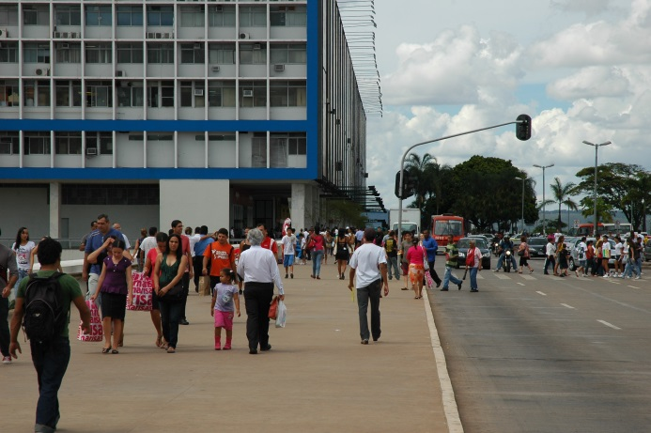

Fig. 9.4

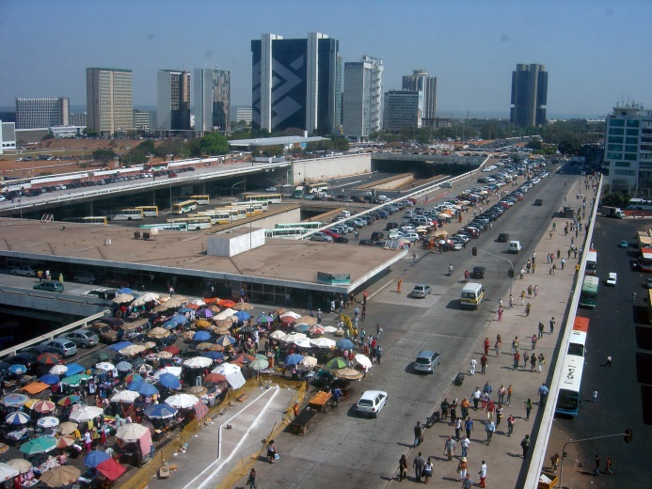

Fig. 9.5

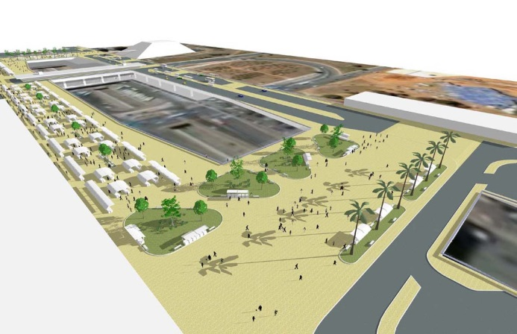

Fig. 9.6

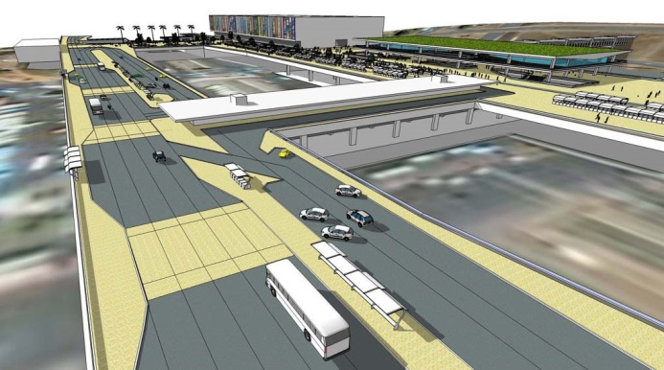

Fig. 9.7

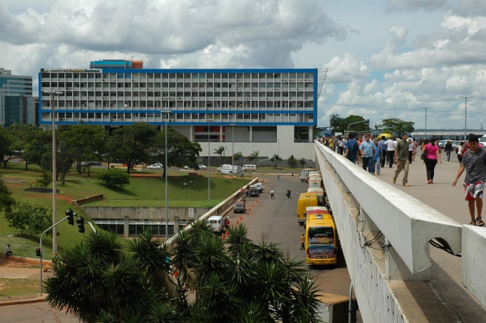

Fig. 9.8

9.5.2 The ironic social utopia

The Village Planalto is a small and isolated neighbourhood 1500 m away from the Three Powers Plaza and 3900 m from Brasília’s Central Business District (CBD). It is the remanence of a camp of contractors that dates from the beginning of the city’s construction, in 1957 (Holanda 2007, Ocaranza and Holanda 2017). The 2010 Demographic Census informs that there were at the time 7361 inhabitants and 1424 plots of land for all uses (IBGE, 2010). It is a place of great variety of plots, buildings, street blocks and public spaces; building height goes up to four stories, but these are rare – the large majority is one and two stories high. Streets and sidewalks also vary in width; some alleys barely allow the passage of vehicles (figures 9.9 and 9.10).
We have compared Village Planalto with various other neighbourhoods in Brasília and its morphological variety is clearly responsible for an amazing social diversity: the distribution of income layers mirrors almost exactly that of the Federal District as a whole, while in the superblocks there is a clear predominance of middle and upper classes (Fig. 9.11). Still, housing policies insist in homogeneous boroughs for the rich or for the poor. Students have proposed neighbourhoods with mixed morphological types (figures 9.12 and 9.13).
It is an irony that a place which predominantly houses the poor, located in the heart of the metropolis, one which was doomed to disappear when the city was ‘ready’ – it was designed as a temporary contractors’ camp – should have become a fascinating example of a democratic space if, by such, we understand a spot in the landscape that is the home for an almost perfect match for the social stratification of society at large: in a compact neighbourhood, architecture plays a crucial part, as commented by Peponis (1989, p 106): ‘If society classifies people in different classes, roles and positions, urban space can be one of the means of reintegration’.

Fig. 9.9

Fig. 9.10

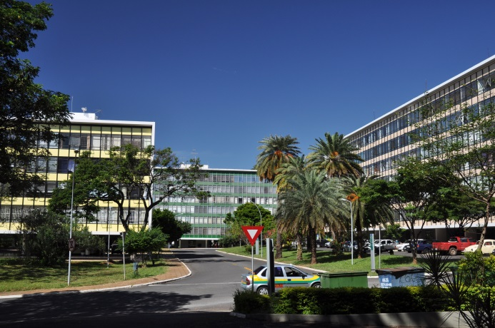

Fig. 9.11

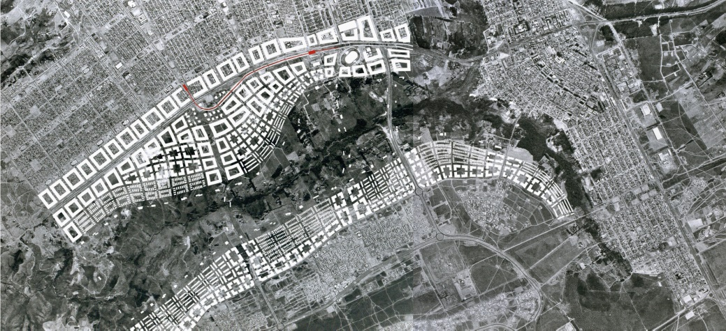

Fig. 9.12

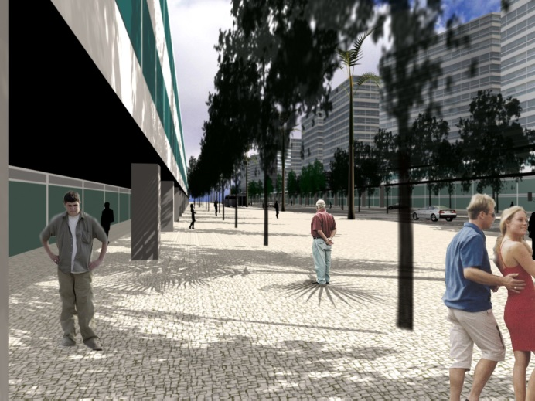

Fig. 9.13

9.5.3 The landscape of objects vs. the landscape of places

In the local jargon, Brasília is said to present four ‘scales’, an unfortunate word for different urban morphological types. These are the monumental, the gregarious, the residential and the bucolic.
The Esplanade of Ministries (Fig. 9.3) exemplifies the monumental space par excellence and, at the same time, represents what I call the ‘landscape of objects’ in its purest version: high percentage of open spaces vs built plots, buildings separated by long distances, clearly legible volumes laid on the ground and ill-defined open morphological units. Buildings are ‘figures’ against a ‘background of space’. The same logic pervades the whole city, although to a less radical degree.
Students are encouraged to make a reverse exercise. Instead of buildings being the ‘end-elements’, they are the ‘mean-elements’ to form avenues, streets, alleys and squares – i.e. clearly defined open space units are the ‘figures’ against a ‘background of solid elements’, rather perceived as ‘walls’ defining streets and squares than three-dimensional volumes (figures 9.14 and 9.15).

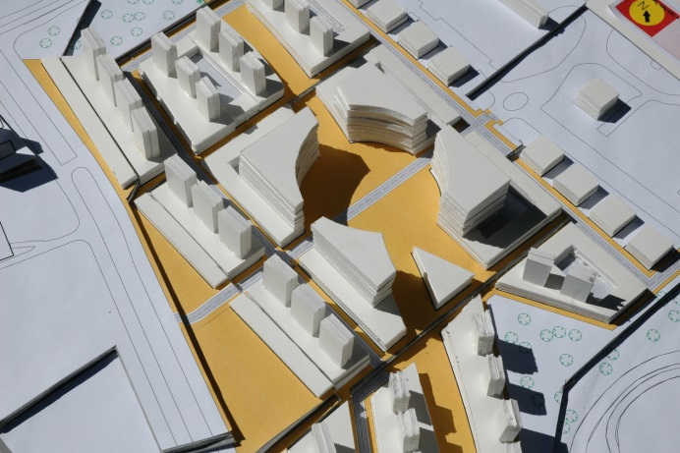

Fig. 9.14

Fig. 9.15

9.6 Conclusion

The history of cities is many things, but it is also the history of clashes amongst contradictory interests of diverse social classes. In some cases – the cases in which we have greater ‘urbanity’ – inequalities in access to the goods and services provided by the city are not great; in others, indeed they are. This is the case with Brasília.
Still, Brasília is not simply that – it is a highly contradictory reality. On the one hand, the dreams of social justice that were present in the discourses underlying its foundations proved false: on the contrary, a drastic social apartheid has developed, more than anywhere else in Brazil. On the other, its expressive qualities are paramount by any standards in history.
The eight-function model helps the students to distinguish amongst diverse aspects of performance; it allows them to understand that monumentality is not necessarily contradictory with a friendly place; that expressive functions may perform well together with practical ones.
We have long applied Bill Hillier’s concept of design as a conjecture-test model. Our research findings have proved useful in demonstrating that you can have intuition and creativity supported by science-based evidence and arrive at novel proposals. Surely, something like the students’ projects awaits actual realization. At first sight, it seems that Brasília as a World Cultural Heritage Site implies difficulties concerning interventions in its physical fabric that would improve its architectural performance. Not necessarily so. Large vacant spaces are one of Brasília’s greatest problems and a great asset, concurrently. There are many instances in which they can be partially occupied – Perez de Arce’s (2015) ‘architecture of additions’ – without damaging the qualities of the city, by preserving the essential attributes of its four urban morphological types (monumental, gregarious, residential and bucolic) and their powerful expressive performance.
Our practice in urban design studios over 40 years exemplifies how important are the precedents brought to bear upon the proposals: ever more often students have been born in Brasilia, and this means that the modern code underlying their design gestures have a very strong say. The first reflexive task is to make them realize that they bring with them a code, not the code; to urge them to widen the morphological repertoire by references to an architectural history more profound both in space and in time; and, most importantly, to challenge them to design spaces, and then buildings and plots and blocks as the means to achieve spatial structure, counter-intuitively as it may seem – for they are conceiving the “void”, the “invisible”, the “nothing”, which constitute the essence of architectural language, in which we immerse ourselves and through which we move (Coutinho 1970, Hillier 1996, Holanda 2015). There is truly a paradigm shift in this, and the shine in students’ eyes when they become conscious of the move could hardly be more rewarding for a teacher.
History is not written in advance. All will depend on the social forces behind architectural actions. The knowledge built on the city of Brasilia may be useful ideological tools for change – as changes have indeed happened along the five odd decades of its brief history, timid as they have been (Holanda 2018). Brasília, the real city, has never coincided literally with Lucio Costa’s proposal: changes haven been implemented since the very first moments the city has risen from the ground. Let it continue to be so – for the better.

Acknowledgments

The author acknowledges a research grant from the Conselho Nacional de Desenvolvimento Científico e Tecnológico, Federal Government, Brazil.

References

Anderson S (ed) (1978) On Streets. MIT Press, Cambridge.
Ballantyne A (2002) Architecture, a very short introduction. Oxford University Press, New York
Castex J, Depaule JC, Panerai P (1977) Formes urbaines: de l’îlot à la barre. Dunod, Paris
Coutinho E (1970) O espaço da arquitetura. Universidade Federal de Pernambuco, Recife.
França FC, Holanda F (2003) My bedroom, my world: domestic space between modernity and tradition. In: Proceedings of the 4th International Space Syntax Symposium: Space Syntax Laboratory, London pp 24.1-24.10
Gehl J (2017) The Modern Movement Put an End to the Human Scale. ArchDaily
Gorovitz M (1985) Brasília, uma questão de escala. Projeto, São Paulo
Hanson J (1998) Decoding homes and houses. Cambridge University Press, Cambridge
Harari YN (2015) Sapiens: a brief history of mankind. HarperCollins Publishers Inc, New York
Hillier B (2011) Is architectural form meaningless? A configurational theory of generic meaning in architecture, and its limits. The Journal of Space Syntax 2:125-153
Hillier B (1996) Space is the machine. Cambridge University Press, Cambridge
Hillier B, Leaman A (1974) How is design possible? Journal of Architectural Research 3:4-11
Hillier B, Leaman A (1976) Architecture as a discipline. Journal of Architectural Research 5:28-32
Holanda F (2002) O espaço de exceção. UnB, Brasília
Holanda F (2003) Atrium-house: an exercise in self-analysis. In: Proceedings of the 4th International Space Syntax Symposium: Space Syntax Laboratory, London
Holanda F (2007) Be aware of local properties. In: Proceedings of the 6th International Space Syntax Symposium. ITU Faculty of Architecture, Istambul, pp 082-01–082-13
Holanda F (2010a) Sociological architecture: a particular way of looking at places. Journal of Space Syntax 1:337-355
Holanda, F (2010b) Brasilia: modern city, eternal city. FRBH, Brasilia
Holanda, F (2010c) Brasília: cidade moderna, cidade eterna. FAU UnB, Brasília
Holanda F (2011) Exceptional space. FRBH, Brasilia
Holanda F (2015) 10 Mandamentos da Arquitetura. 2nd Ed. FRBH, Brasília
Holanda F (2018) Urban fissures. The Journal of Space Syntax 7
Holanda F, Medeiros V (2012) Order & Disorder in Brasilia & Chandigarh. In: Proceedings of the 8th International Space Syntax Symposium. Pontificia Universidad Católica de Chile, Santiago
IBGE (2010) Sinopse por setor censitário. IBGE, Rio de Janeiro
Kern AP, Schnek ER, Mancio M, González MA, Kulakowski M, Dias MF. Habitação de interesse social:relações entre o tipo arquitetônico dos empreendimentos e impactos ambientais. In: Netto VM, Saboya RT, Vargas JC, Carvalho T. (ed) Efeitos da arquitetura: os impactos da urbanização contemporânea no Brasil. FRBH, Brasília
Kohlsdorf G, Kohlsdorf ME (2017) Ensaio sobre o desempenho morfológico dos lugares. FRBH, Brasília
Kruft H (1994) A history of architectural theory from Vitruvius to the present. Princeton Architectural Press, New York
Lynch K (1999) A imagem da cidade. Martins Fontes, São Paulo.
Mascaró JL (1985) O custo das decisões arquitetônicas. Nobel, São Paulo
Mitchell WJ (2000) E-topia. The MIT Press, Cambridge
Neufert E, Neufert P (2004) Arte de projetar em arquitetura. Gustavo Gili, Barcelona
Norberg-Schulz C (1979) Genius Loci: towards a phenomenology of architecture. Rizzoli, New York
Ocaranza M, Holanda F (2017) Learning from vila planalto: the limits of segregation and urban diversity in a gentrified neighbourhood. In: Proceedings of the 11th Space Syntax International Symposium, Instituto Superior Técnico, Lisboa, p 2358-2371.
Peponis J (1989) Space, culture and urban design in late modernism and after. Ekistics 56:93-108
Pérez de Arce R (2015) Urban transformations and the architecture of additions. Routledge, London
Popper K (1976 [1963]) Conjectures and refutations – the growth of scientific knowledge. Routledge and Kegan Paul, London
Prinz D (1980a) Urbanismo I: projecto urbano. Editorial Presença, Lisbon
Prinz D (1980b) Urbanismo II: configuração urbana. Editorial Presença, Lisbon
Romero M (1988) Princípios bioclimáticos para o desenho urbano. Projeto Editores, São Paulo
Rossi A (1982[1966]) The architecture of the city. MIT Press, Cambridge
Santos CNF, Vogel A (1985) Quando a rua vira casa - a apropriação de espaços de uso coletivo em um centro de bairro. Projeto Editores, São Paulo
Scruton R (2013) The aesthetics of architecture. Princeton University Press, Princeton
Scully V (1989) Pueblo: mountain, village, dance. The University of Chicago Press, Chicago
Seamon D (2000) Phenomenology, place, environment, and architecture: a review of the literature. Environmental & Architectural Phenomenology
Silva E (1985) Arquitetura e semiologia. Ed. Sulina, Porto Alegre
Vitruvius MP (1960[27 BC)]) The ten books on architecture. Dover Publications, New York

Frederico de Holanda Universidade de Brasilia Brasilia, Brazil fredholanda44@gmail.com

